SWOT analysis

What is it?
SWOT stands for
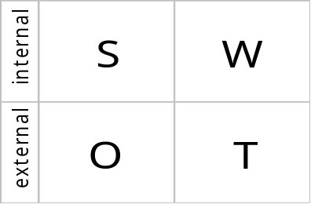
- Strengths -
- Weaknesses
- Opportunities
- Threats
SWOT analysis is a tool for auditing an organisation and its environment. It is often the first tool in the planning process because it helps to identify and analyse key issues.
How can it help me?
One of the key aspects of strategic planning and management is being proactive. This means making decisions that take advantage of strengths and opportunities, overcome weaknesses, and attempting to turn threats into opportunities. SWOT offers a starting framework for perceiving the organisation’s current situation.
How is it used?
Brainstorm and record a list of SWOTs – strengths, weaknesses, opportunities and threats. Ask your self the following questions.
- What are the organisation’s internal strengths? What do you do well?
- What are the organisation’s internal weaknesses? Where can you improve?
- What external opportunities exist? What changes are happening ‘out there’ that might help you to better achieve your mission?
- What external threats might hinder the pursuit of your mission?
Some factors may appear under more than one category and different people may perceive things in different ways. Have as many people involved as is practical, made up of a broad cross section of your stakeholders.
What do we do next?
The key thing is the analysis; once you have your lists of strengths, weaknesses, etc, what do they mean? Be aware that SWOT analysis can be a very subjective thing, and that not all the factors you identify will have the same level of significance. Use it as a guide and not a prescription.
Although gathering a list of SWOT items is often carried out as a single group activity using a flipchart, it is useful to include as many people as possible; a SWOT exercise undertaken by your users could give very different results to one carried out within your staff team. Try gathering lists of SWOTs using telephone interviews, questionnaires or personal interviews.
The following points will help you to get more out of your SWOT analysis.
- People have a tendency to concentrate on the weaknesses and threats: try asking everyone to list a minimum number of strengths and identify at least one opportunity.
- Perceptions will differ wildly, particularly amongst different stakeholder groups, and what some people see as a weakness others may see as a strength. For example, one person’s friendly informality could be another’s disorganised mess. Further investigation of different and apparently contradictory perspectives can be very valuable.
- Some things will be neither an opportunity nor a threat. During a period of change, for example, things could go either way. Try to explore ways of making sure that potential threats become positive opportunities.
- Don’t concentrate purely on overcoming weaknesses. Look at your strengths and try to understand both what makes them strengths and how you can build on your strengths for the future.
- Try placing your SWOTs into logical topic or issue groups, such as staffing, premises and so on. This will help you to focus on particular issues, but also try to see how these bigger issues interrelate.

